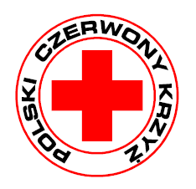

Malopolska Regional Department of Polish Red Cross Volunteer’s Form

Name and surname
Date and place of birth
Identity card number and Personal Identity Number
Home address (postal code, city/town, street)
Phone number
e-mail address
Name and address of school or workplace
Formal education, finished courses and trainings
Foreign languages (level of acquisition)
Interests/preferences
(Abilities, hobbies, etc.)
What would you like to do for Polish Red Cross (PCK)? | 1.  2.  3.  4.
Have you worked as a volunteer before?
If yes, what did you do?,
Why would you like to work as a volunteer?

Time available Please sign with X suitable Boxes.
In the Morning | Monday | Tuesday | Wednesday | Thursday | Friday | Saturday | Sunday
In the afternoon
In the evening

Notice!
In the case of a minor it requires the written consent of a parent / legal guardian of the child volunteering activity in Malopolska Regional Department of olish Red Cross.
I consent to the processing of my personal data contained in this form is required in connection with the activities of Malopolska Regional Department of Polish Red Cross volunteering and to inform me about the implementation of activities (in accordance with Art. 23, paragraph 1, item 1 of the Act of 29 August 1997. On the protection of personal data).

